# Ling 165 Lab 4: September 1, 2013

## Content selection for single-document summarization

# Lab components:

|  |  |
| --- | --- |
| /home/students/ling165/lab4/newyorker.txt | A text-file-version of a New Yorker article. The file contains about 2,021 words (per M’soft Word word count). |
| /data/brown | A directory containing 500 Brown Corpus documents (whose words are marked-up with POS tags, as in “word/POSlabel”. |
| /home/students/ling165/lab4/clean.py | A script Hahn provided to clean-up the character encoding in the text file. Use this file first, externally to my own coding, and just overwrite the filename (newyorker.txt) for the output. |
| /home/students/ling165/lab4/llr.py | Functions Hahn provided for the log-likelihood calculations. |

# What we need to do:

This project doesn’t have us do the full scope of a “summarization” or “text retrieval” project, but demonstrates two different approaches to determining the most “important” words in a document. We need to provide two different lists of top-twenty words, one created using tf-idf approach, the other using the log-likelihood approach.

I’d like my script to perform both tasks in the same script so that I can print out a report at the end of the run. The report would look as follows:

Lab 4 Results

Top-twenty words (newyorker.txt)

tf-idf llr

word1 word1

word2 word2

word3 word3

. . . . . .

word20 word20

[kwiseth@gray lab4]$ python ling165_lab4.py

To do this, I’ll have to keep track of the rankings per approach.

# Pseudo-code, processing flow for tf-idf

### tf

To start, let’s build a dictionary of words and their counts from the newyorker.txt file. this will provide the tf (term frequency) information.

1. Open the newyorker.txt file
2. Go through the document line by line and build up dictionary of words and counts.
3. When this dictionary is created, we’ll have a complete inventory of words and their counts.
4. Use this dictionary to the process all 500 of the documents in /data/brown in the next phase (idf).

What about using **pop()**? for some of our dictionary cleanup? This is a dictionary method that can delete a key.

tf.pop(key) if key in stopwords <- Explore this further and learn about using it.

sum(tf.values()) Total word count in our tf{dict}. We don’t need this for tf-idf, but will for LLR. This is item (14) total number of words in the given document” from lab instructions.

### idf

for each word in tf dictionary:

Make the list of documents in /data/brown [this should be done outside the ‘for-loop’—prepare the list in advance and just leave it saved locally]??

Open each document

Break on “/” or replace “/” with “<spaceband>” so that the words stand alone??? (if we break on “/,” will we end up with just the words and their POS separated?)

Regular expression: (/.*) ?? No—easier to just break the words on the slash.

Get the first word in the term-frequency dictionary:

If the tf[word] in doc:

add one to the doc_ctr for this word [THIS NEEDS TO BE CREATED SOMEWHERE—FOR EACH WORD.   
  
Maybe the tf[dict] has two values as a tuple: { word : (int, int) } ??? So by the end of the first phase, we’ll have a dictionary containing counts of all the words in the newyorker.txt, but the second digit should be 0 (or maybe 1—should we count the newyorker.txt itself at this point, or later, for purposes of calculating idf??

if key in brown_doc_words:

doc_ctr += 1

~~else:~~

~~doc_ctr += 0~~

return doc_ctr

Think about it: the “else” isn’t needed, and more to the point, we’re resetting our doc_ctr back to 0 each time we don’t have a document!! THINK, grasshopper!

If we build the dictionary to keep track of both numbers (word count in newyorker, document count for that word in data/brown, at this point we need to use the data to perform the calculation—“the log of the reciprocal of the proportion of documents containing the word in a collection of documents:”

tf = tf[word][0] gives us the word count

idf = 501/[word][1]

tf-idf = tf * math.log(idf) result; order these from largest to smallest

## Status Notes

5-August-2013

I have the **tf** dictionary built, but it still has some issues. Specifically, we have some punctuation as words (hyphen, single quote, quotation mark), which would be simple enough to clean up, but we also are breaking-up some words that are hyphenated to begin with (“forty-two,” for example)—these should be retained as words.

Also, word sequences such as “output per hour”—these would be nice to maintain as single units. Similarly, names such as “San Francisco”—we are counting these as instances of “san” and “francisco,” but these should probably be kept together.

brown documents: I have a dictionary containing a document id number (beginning with 0) and just the text of the document as one big string.

In general, this is an issue with the concept of “term frequency” in any summarization or retrieval task (full discussion in *Introduction to Information Retrieval* (Manning, Raghavan, and Schütze: 2008; 21-27).

Output below is using **newyawker.txt**

-------------------------------------------------------------------------------

Word tf-idf Word llr

--------------------------------------------------------------------------------

1 productivity 118.007

2 growth 50.594

3 Internet 37.300

4 technology 28.219

5 percent 27.631

6 Gordon 27.384

7 optimists 24.866

8 computers 23.026

9 benign 22.086

10 inventions 19.313

11 slowdown 18.650

12 online 18.650

13 economists 17.675

14 nineties 15.354

15 Web 15.227

16 standards 13.816

17 impact 13.816

18 recession 12.788

19 twenty 12.477

20 inputs 12.433

[kwiseth@gray lab4]$

Output below is using **newyawker2.txt**

Lab 4 Results: Top-twenty Words (Descending order)

--------------------------------------------------------------------------------

Word tf-idf Word llr

--------------------------------------------------------------------------------

1 productivity 110.393

2 growth 48.648

3 percent 27.631 forget about combining these words and

4 Gordon 27.384

5 technology 25.084

6 optimists 24.866

7 Internet 24.866

8 computers 23.026

9 benign 22.086

10 inventions 19.313

11 slowdown 18.650

12 online 18.650

13 economists 17.675

14 Web 15.227

15 standards 13.816

16 impact 13.816

17 recession 12.788

18 inputs 12.433

19 Silicon 12.433

20 desktop 12.433

[kwiseth@gray lab4]$

**DO THIS LATER**—get rid of my text cleanup (‘per cent’, output-per-hour… and compare results--- show three different options

### Normalizing the New Yorker article text

“Token normalization is the process of canonicalizing tokens so that matches occur despite superficial differences in the character sequences of the tokens.” (Manning, Raghavan, Schütze: 26)

### Brown Corpus

Initial runs of my script are identifying the years (2005, 2004, for example) with high tf-idf scores, but then I realize this is likely due to the fact that Brown Corpus is from the 1960s (with an update in the 1970s it seems), so I should probably disregard dates and numbers (“1.5” is registering a high tf-idf). I think I’ll look solely for words as terms, and disregard numeric values.

## TODO

**Coding style:** Go through the script when it’s all done and look for opportunities to use list comprehensions instead of for-loops. Need to really learn how to use this structure!

Need to learn how to properly access items. Would this work to add an int value to my {tf} dictionary to keep track of the count of brown docs in which the word appears? I’m not sure this makes sense.

for key in tf:

if key in brown_doc:

tf[‘key’][1] += 1

### tf dictionary

Print out the dictionary and make sure it’s clean.

For my dictionary, I’d like to keep hyphenated words together as unit (“forty-eight”), so this implies that the words should be collected without first eliminating punctuation—which means that Hahn’s script adds spaces around such words and therefore treats them as single words “forty”, “eight”.

I should try this entire script both with and without the various cleanup routines and see how the results vary.

Some other words should likely also be kept together: for example, “output per hour” is a single concept, and conceivably could be hyphenated. This implies a lookup table or list of some kind, though, since we can’t make decisions about keeping words together without some additional materials. Look at Jurafsky text closer and see what his chapter says.

Some alternatives to consider for the dictionary: Minimize the amount of preliminary cleanup and just delete punctuation and other detritus from the dictionary after it’s built.

Similarly, delete the **stopwords** from the dictionary after it’s built.

TODO: Do I want to try to add the counts from the brown documents to the {tf} dictionary for my idf processing? The dictionary would ultimately look like:

{ word : (int1, int2)} where **int1** is the count of the word in the neworker.txt and **int2** is the number of brown docs in which the word appears.

To the int2 we add a 1 to account for the newyorker.txt count.

### brown data

For the brown data, I’m just breaking on the “/” and then gathering up the first word and disregarding the “POS-tag,” restring together as first a list, then build new string. The end result is on big string containing the entire text of the document. This is associated with an index number in a dictionary. I’m also disregarding punctuation, such as periods, commas, and quotes.

TODO: Check how well my routines handle possessives. Are there any hyphenated words in my resulting brown data??? If not, it means I shouldn’t care if my dictionary {tf} has hyphenated words or not. I should be consistent in how I gather words for {tf} and how I gather words in my brown documents.

### find the words from the dictionary in the documents

Need to go through the dictionary, get each word, and then go through all 500 documents in my brown {dictionary} and keep track of the number of documents in which the word in question appears.

## Log-likelihood Ratio

For LLR, we also build a dictionary. We can use the same general loop as tf, but our structure is different.

fd = {} ‘word’

ADD DISCUSSION

## Results

These results use the New Yorker text without modifying the copy, other than eliminating numeric values.

--------------------------------------------------------------------------------

Word ranked by ttf-idf Word ranked by llr

--------------------------------------------------------------------------------

1 productivity productivity

2 growth growth

3 output Gordon

4 Gordon optimists

5 technology Web

6 optimists Internet

7 Internet computers

8 computers benign

9 benign time

10 inventions technology

11 slowdown output

12 online slowdown

13 economists online

14 Web inventions

15 standards economists

16 impact good

17 recession work

18 inputs cent

19 Silicon back

20 desktop inputs

[kwiseth@gray lab4]$

[kwiseth@gray lab4]$

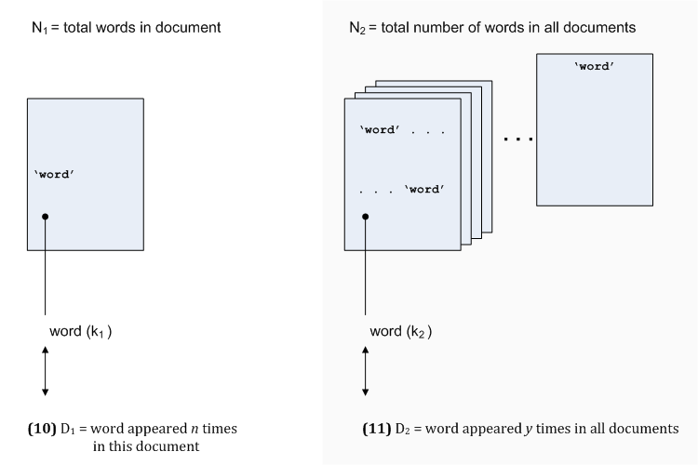

Mapping the instructions to variables in my code:

(3) corpus size = 500 documents + 1 (New Yorker article) = 501

|  |  |  |
| --- | --- | --- |
|  |  | Variable name, value |
| (3) we have a corpus size… | 501 | len(brown_doc_map) + 1 |
| (4) summarize one of them… | newyorker.txt |  |
| (5) is word x a keyword | tf[key] (key = *word*) | {tf[key] : int } |
| (6) count of word in document | int value |
| (7) number of other documents containing that word |  | brown_doc_ctr |
|  |  |  |

tf dictionary { word : int } where *int* is count of word in newyorker.txt

brown_doc_map { int : str } where *int* is index number of document from list (0-499) and *str* is text of brown doc as one big string

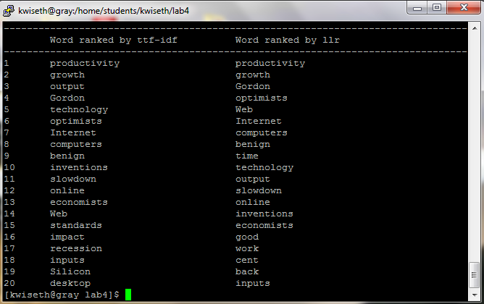

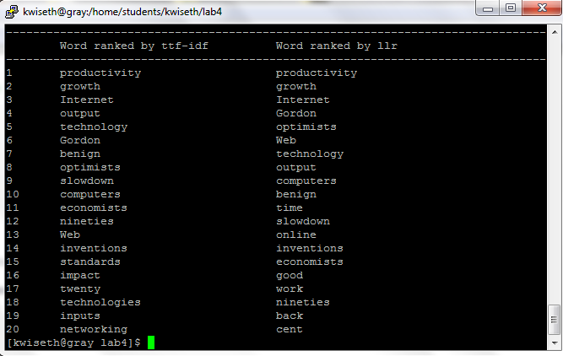

The result (Figure 4.1) uses a previous versionloop that does not remove dates. Since the brown corpus is from the 1960s (and I believe updated in the 1970s), it makes sense that dates in the future would have few tokens in the brown corpus (is my thinking correct here?), and thus these dates would emerge as “informative.” However, if we decide that dates should not be counted as “terms” and we remove them, the results are different (see Figure 4.2).

Figure 4.1: Not removing dates from the list of terms in the New Yorker article

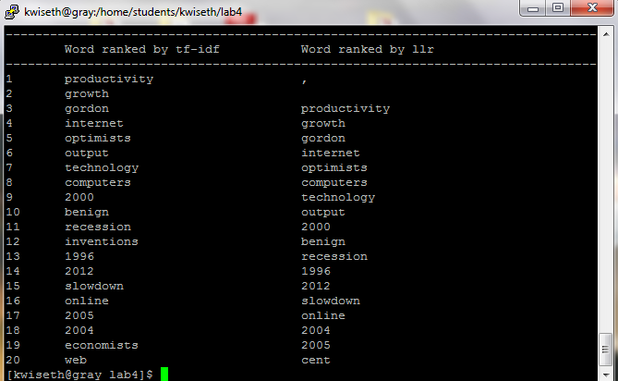

## 28 – August [Results after figuring out my brown-doc loop was WRONG and fixing it ]

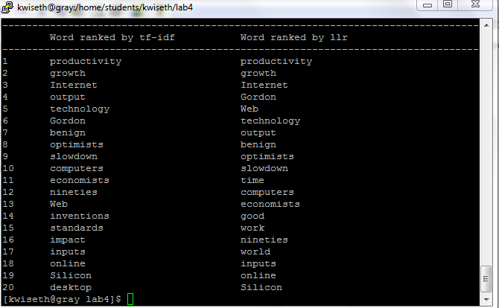

Things I concerned myself with unnecessarily:

stopwords, hyphens, dates and numbers—I had initially thought that I’d need to clean these things up, but discovered that it was unnecessary—which, I suppose, is the whole point of these algorithms (tf-idf and llr)! they identify the most informative words based strictly on counts of things…

Initially,

I also tried a version of the script that performed minimal clean-up of the text, but the punctuation and many stopwords surfaced in the top-20 counts, so this final version includes a lot of massaging of the text.

Reasons:

Eliminating dates and years:

Since we’re using the Brown corpus (which was last updated in the 1970s I think??), years such as “2004” emerge in the top-20 list, since this appears in the document but perhaps not at all in the brown document counts.

Since the documents in the /data/brown directory include POS tags, we have to get just the words without the tags. Also, we should leave the capitalization alone, both in the New Yorker article and in the /data/brown files.

These results using the “get_words()” function.

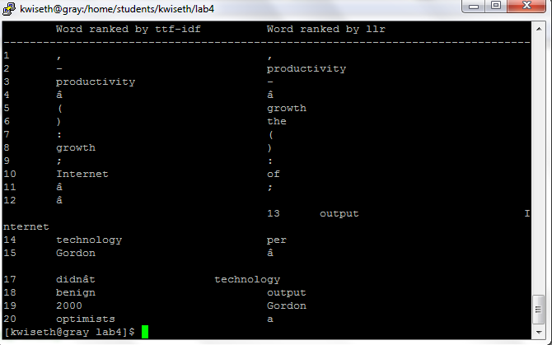

Figure: 4.1 -Aug

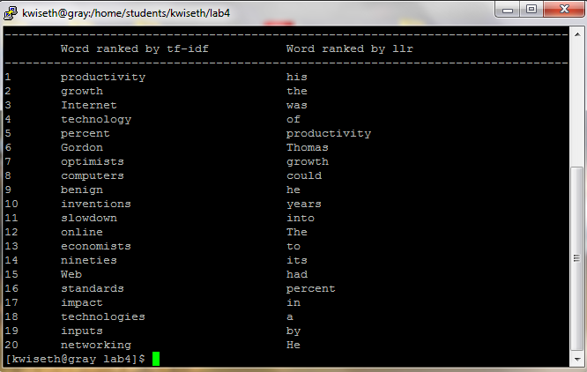

I would have thought that the frequency of the various stop-words, particularly words like ‘the’ and ‘of’ and ‘to’ etc would have been eliminated when compared to the total word counts across the brown documents, so this leads me to think that I’m still doing something wrong in Lab 4’s code. As a workaround, I’m adding a loop to eliminate the stop-words from the dictionary before I pass it to the llr function.

